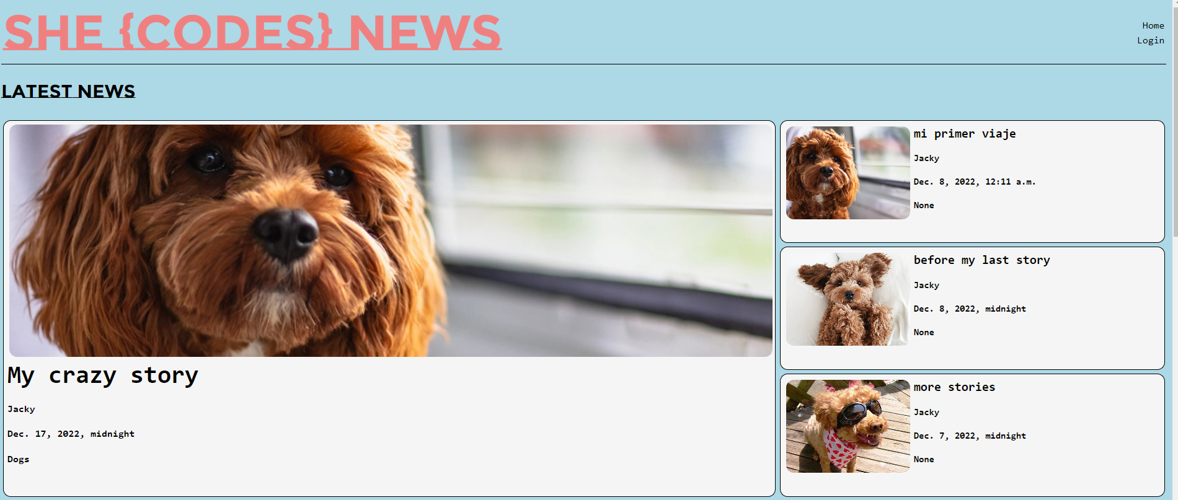

After login

Create account

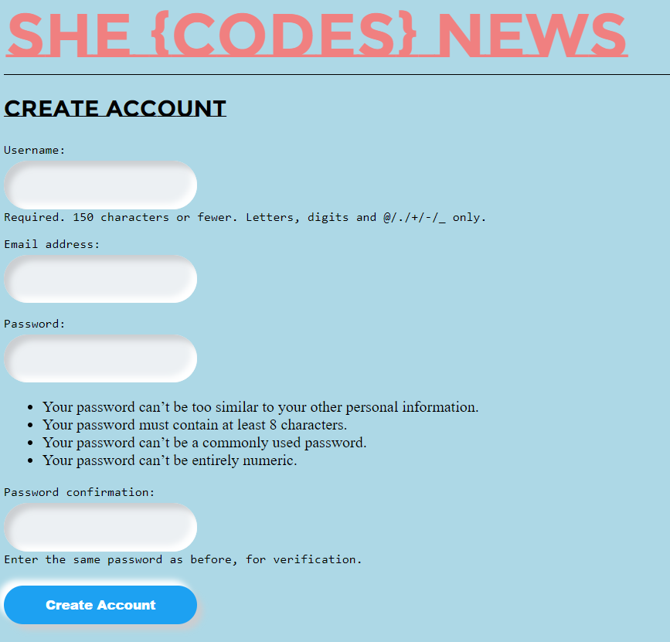

Edit profile

post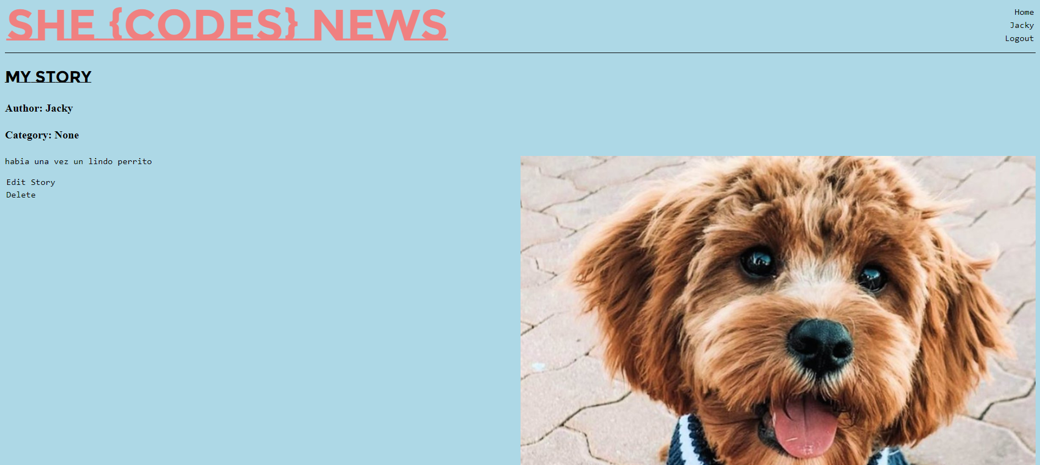

Edit post

Delete post

